KWAME NKRUMAH UNIVERSITY OF SCIENCE AND TECHNOLOGY



COLLEGE OF ENGINEERING

DEPARTMENT OF MECHANICAL ENGINEERING

BSc. MECHANICAL ENGINEERING

LABORATORY EXPERIMENT: PUMP TEST

LECTURER: DR. Y. A. K. FIAGBE

TECHNICIAN: MR. DAVID MINGLE

LAB GROUP M

**GROUP MEMBERS**

| **NAMES** | **INDEX NUMBERS** |
| --- | --- |
| Asante Bright Larbi | 3623118 |
| Adomah Musah | 3619718 |
| Ampomah Calvin Patrick | 3621518 |
| Cobbinah Titus | 3624718 |
| Mills Vanessa Naa Lamiokor | 3627518 |
| MacDans Victoria Boadiwaa | 3627418 |
| Adusei Mensah Bright | 3620018 |
| Okorie Onyedikachukwu Vincent | 3634518 |

INTRODUCTION

Centrifugal pumps are most commonly used for water or similar liquids of low viscosity. The main characteristics of a centrifugal pump are 1.High flow rate at moderate pressure 2.Flow that can be varied simply using the valve( closing the valve does not cause problems)

3.Not self- premier so the pump action should be flooded at all times.

4. Flow that falls with increasing system pressure reducing pump speed

The centrifugal pump supplied consists of a single impeller incorporated radial blades that rotate inside a snail-shape volute casing. Water enters axially at the eye of the impeller, spirals outwards and discharges at the peripheral of the impeller into the volute casing. As the fluid passes through the pump, energy is impacted to it by the blades of the Impeller resulting in fluid leaving the impeller with an increase with an increase of both pressure and velocity.

Are capable of transferring large volumes without dependence on valves or fine clearances and can be run against a closed valve without ldeveloping a very high pressure.

**AIM OF THE EXPERIMENT**

Investigate the performance characteristics of a centrifugal pump

**SETUP**

**DIAGRAM OF THE CENTRIFUGAL PUMP**

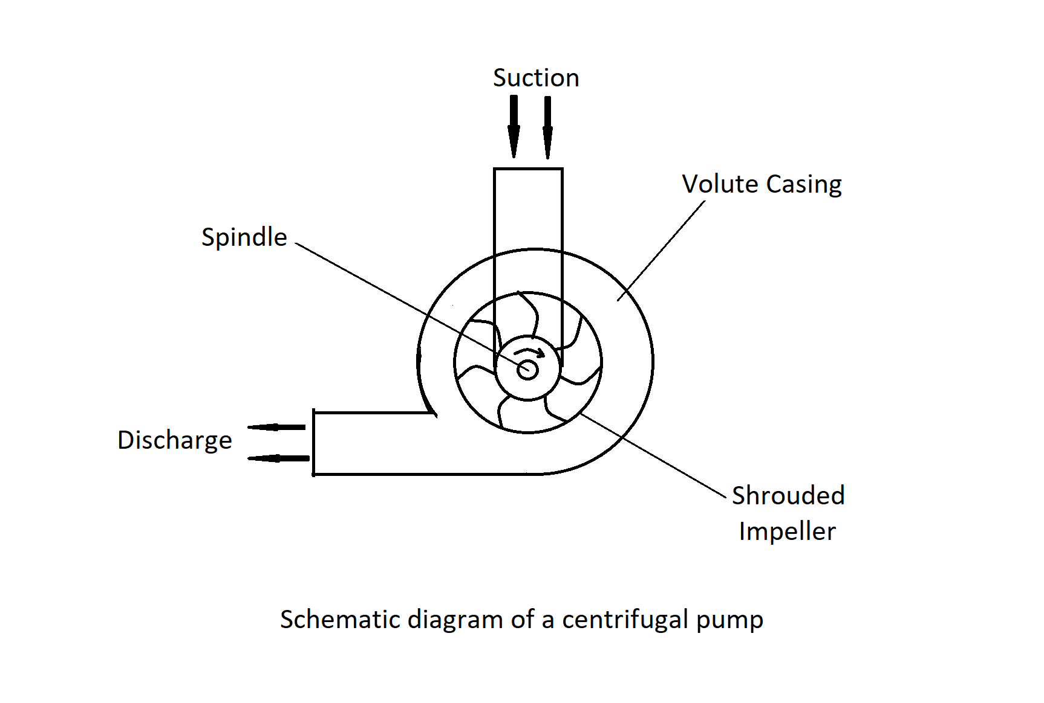

**EXPERIMENT SETUP:**

The centrifugal pump is permanently fitted to the C3-MKII and no changes are required for this exercise. It is advisable to retain the end-caps on the unused piping unless additional pumps have been connected to the low-pressure system.

Check that the reservoir on the C3-MKII has been filled with clean water and that the equipment is connected to an appropriate mains electricity supply.

If a thermometer is available remove the reservoir lid and measure the temperature of the water. Remove the thermometer and replace the reservoir lid.

Check that the USB cable is connected from the electrical console to the PC. Load the C3-MKII software then choose the centrifugal pump from the main menu. Check that **IFD:vCOM(x)m** is indicated in the bottom right hand corner of the screen where x is the number of the USB port.

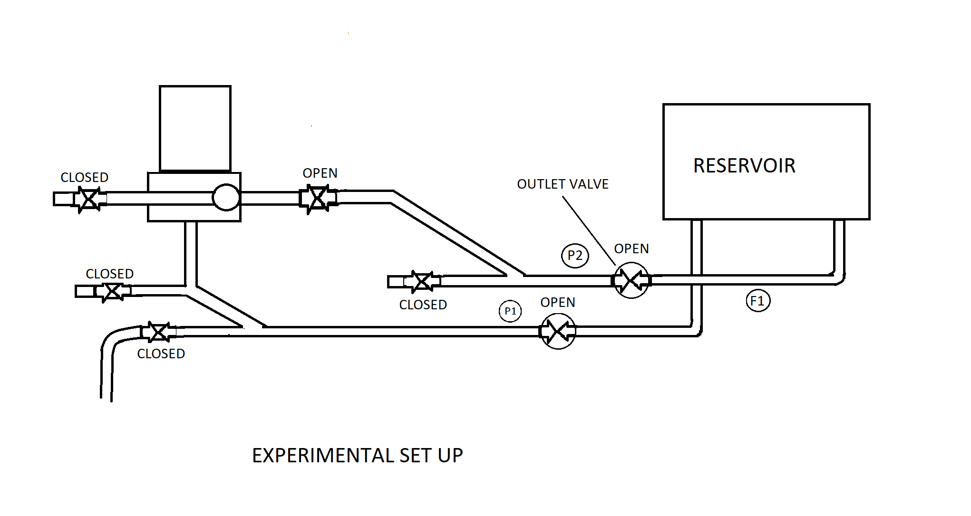

**PROCEDURE:**

We used the outlet valve only to adjust the discharge from the centrifugal pump. The other valves remained open or closed throughout the exercise, as marked on the diagram above. We started with the outlet valve fully open.

We connected the mains supply to the equipment then switch on the power switch on the electrical console.

If ‘Low Level’ is displayed on the mimic diagram fill the reservoir to approximately 75 mm from the top then confirm that the warning has disappeared.

If the temperature of the working fluid in the reservoir is known, enter the value in the box provided on the mimic diagram. The value will default to 20.0˚C if the actual value is not entered.

We run the pump at maximum speed for the first part of this exercise. We gradually increased the speed of the pump from 0% to 100% by clicking the ‘Pump Speed’ up button until the pump is running at maximum speed of 100%.

With the pump at 100% speed, we allowed the pump and pipe work to fully prime.

When the flow reading was steady, we clicked the (GO) icon and recorded all the of the instantaneous measured and calculated variables into the results table.

We gradually closed the outlet valve until the flow reading falls slightly, we then allowed the conditions to settle and recorded another set of readings by clicking the (GO) icon.

We continued to close the outlet valve in steps and record a set of values at each step until a flow rate of 0 l/min was reached. We recorded one more set of readings for zero flow conditions.

We then recorded additional sets of results for different pump speed settings, for example at 90%, 80% etc until the flow and pressure readings were minimal.

When sufficient readings have been taken, we then reduced the pump speed to 0% to stop the pump.

**TABLE**

| INLET  (kPa) | OUTLET  (kPa) | SPEED  (rpm) | TORQUE  (Nm) | FLOW RATE  (1/min) | TEMPERATURE (°C) | DENSITY  (kg_m³) |
| --- | --- | --- | --- | --- | --- | --- |
| -17.17 | -1.11 | 1 | 0.023 | 0.0 | 20 | 1000 |
| -17.47 | 14.24 | 2849 | 1.192 | 206.4 | 20 | 1000 |
| -16.97 | 34.14 | 2849 | 1.057 | 172.1 | 20 | 1000 |
| -16.71 | 55.65 | 2849 | 0.870 | 137.6 | 20 | 1000 |
| -16.61 | 71.27 | 2847 | 0.703 | 103.3 | 20 | 1000 |
| -16.46 | 91.91 | 2849 | 0.595 | 65.4 | 20 | 1000 |
| -16.21 | 88.67 | 2849 | 0.651 | 68.8 | 20 | 1000 |
|  |  |  |  |  |  |  |
|  |  |  |  |  |  |  |
|  | FOR THE | 80 |  |  |  |  |
|  |  |  |  |  |  |  |
|  |  |  |  |  |  |  |
| -16.06 | 95.95 | 2849 | 0.750 | 34.5 | 20 | 1000 |
| -15.45 | 3.64 | 2565 | 0.955 | 192.7 | 20 | 1000 |
| -15.00 | 25.35 | 2565 | 0.886 | 161.7 | 20 | 1000 |
| -14.45 | 43.13 | 2565 | 0.716 | 130.7 | 20 | 1000 |
| -14.39 | 62.82 | 2565 | 0.745 | 96.4 | 20 | 1000 |
| -14.29 | 71.00 | 2565 | 0.708 | 65.4 | 20 | 1000 |
| -14.04 | 78.88 | 2565 | 0.606 | 31.0 | 20 | 1000 |
|  |  |  |  |  |  |  |
|  |  |  |  |  |  |  |
|  |  |  |  |  |  |  |
|  |  |  |  |  |  |  |

**Calculations**

a. Total Head, $H_{t}$

$H_{t}=H_{s}+H_{v}+H_{e}$

Where;

$H_{s}$ = Change in static head

$H_{v}$ = Change in velocity head

$H_{e}$ = Change in elevation

But;

$H_{s}= \frac{\left(p_{out}-p_{in}\right)}{ρg}$

Where;

$p_{in}$ = $p_{1}$ = Measured fluid pressure at the inlet $N/m^{2}$

$p_{out }$ = $p_{2}$ = Measured fluid pressure at the outlet $N/m^{2}$

And;

$H_{v}=\frac{{\left(V_{out}-V_{in}\right)}^{2}}{2g}$

Where;

$V_{in}$ = Fluid velocity at the inlet in $m/s$

$V_{out}$ = Fluid velocity at the outlet in $m/s$

For this application however, the fluid is considered to be incompressible. Also knowing that the cross-sectional area at both pressure tappings is the same so

$V_{in} = V_{out}$

and thus; say, $V_{in} = V_{out} = V$

$H_{v}=\frac{{\left(V_{out}-V_{in}\right)}^{2}}{2g}$

$H_{v}=\frac{{\left(V-V\right)}^{2}}{2g}=\frac{0}{2g}=0$

$H_{v}=0$

$H_{v}=$ Change in elevation = Vertical distance between the inlet and the outlet sensors

But since both the sensors are calibrated to read 0m with the reservoir full, and already $H_{v}=0$,then;

$H_{e}=0$

$H_{t}=H_{s}+H_{v}+H_{e}= H_{s}+0+0= H_{s}$

$H_{t}= H_{s}$

b. Mechanical Power Input, $P_{m}$

$P_{m}= \frac{2πNT}{60}$

Where;

$N=N_{1}=$ Measured rotational speed of pump in $rpm$, (Revolutions per minute)

$T= T_{1}$ = Measured torque in $Nm$

c. Overall Pump efficiency, ${}_{p}$

${}_{p}=100 ×\frac{P_{h}}{P_{m}} \%$

Where;

$P_{h}=$ Hydraulic Power imparted to fluid by the pump measured in $Watts$

$P_{m}$ = The mechanical power input to the pump

$P_{h}= ρgQH_{t}$

Where;

$Q$ = Discharge Volume Flow rate in $m^{3}/s$

All the parameters above are calculated from the appropriate measured values provided by the software supplied with C3-MKII

| Flow rate, ($Q$) $m^{3}/s$ | ΔStatic Head,  ($H_{s}$) $m$ | ΔElevated  Head, ($H_{e}$) $m$ | ΔVelocity  Head,  ($H_{v}$) $m$ | Total Head,  ($H_{t}$) $m$ | Power Input,  ($P_{m}$) $W$ | Hydraulic  Power,  ($P_{h}$) $W$ | Eff.  (${}_{p}$)  % |
| --- | --- | --- | --- | --- | --- | --- | --- |
| 0.003441 | 0.68 | 0 | 0 | 0.68 | 293.8 | 22.9 | 7.8 |
| 0.002869 | 3.68 | 0 | 0 | 3.68 | 271.2 | 103.4 | 38.1 |
| 0.002294 | 5.83 | 0 | 0 | 5.83 | 265.6 | 131.2 | 49.4 |
| 0.001722 | 7.93 | 0 | 0 | 7.93 | 243.9 | 133.8 | 54.9 |
| 0.001147 | 9.34 | 0 | 0 | 9.34 | 186.8 | 105.1 | 56.3 |
| 0.000575 | 9.95 | 0 | 0 | 9.95 | 210.3 | 56.1 | 26 |

| Flow rate, ($Q$) $m^{3}/s$ | ΔStatic Head,  ($H_{s}$) $m$ | ΔElevated  Head, ($H_{e}$) $m$ | ΔVelocity  Head,  ($H_{v}$) $m$ | Total Head,  ($H_{t}$) $m$ | Power Input,  ($P_{m}$) $W$ | Hydraulic  Power,  ($P_{h}$) $W$ | Eff.  (${}_{p}$)  % |
| --- | --- | --- | --- | --- | --- | --- | --- |
| 0.003155 | 0.69 | 0 | 0 | 0.69 | 255.6 | 21.3 | 8.4 |
| 0.002638 | 3.35 | 0 | 0 | 3.35 | 239.2 | 86.6 | 36.2 |
| 0.002123 | 4.66 | 0 | 0 | 4.66 | 194.3 | 97.1 | 50 |
| 0.001607 | 6.54 | 0 | 0 | 6.54 | 203 | 103.1 | 50.8 |
| 0.001032 | 7.75 | 0 | 0 | 7.75 | 155.4 | 78.5 | 50.5 |
| 0.000517 | 8.26 | 0 | 0 | 8.26 | 138.2 | 41.8 | 30.3 |

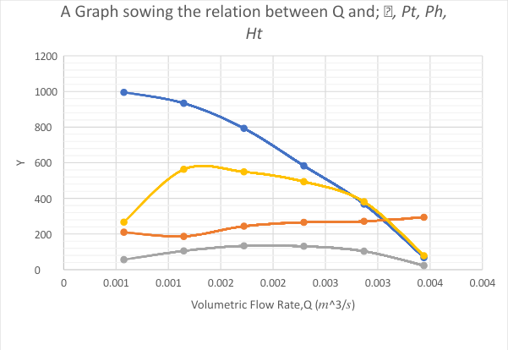

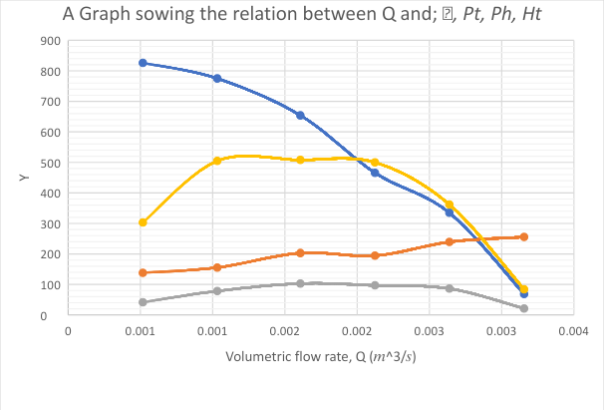

**DISCUSSION:**

* From the pump performance curve, we can see that the maximum volume flow rate through a pump occurs when its net head is zero, H=0; this flow rate is called the pump’s **free delivery**. The free delivery condition is achieved when there is no flow restriction at the pump inlet or outlet or when there is no **load** on the pump.
* In these two speeds, all value for water head pump from the start to the end of the experiment is decreased. This is because due to starting point of the discharge pressure where we slowly decreased the amount of pressure in certain gap, and as expected it effect the value of water head result.
* For output power, we can say the more speed is occurred in the experiment, the bigger number of output power will be produced.
* For the efficiency, the number of the effectiveness of the experiment data is increasing due to the increasing value of the speed. To get the better efficiency, the rate of power output and input must be bigger.

**CONCLUSION :**

From the experiment, the characteristics of this pump which is the efficiency, the input and output power and the head can be defined by using a different speed of pump. Thus, the objective of this experiment is achieved in order to define any centrifugal pump characteristics.

It also can be concluded that the main objectives of this experiment have been achieved successfully. The flow rate decreases as the speed decreases with pressure. The torque decreases as the power decreases.